ASSESMENT-3


K. R. MANGALAM UNIVERSITY B. Tech (AI & ML) SOET
(School of Engineering and Technology)

NAME: Anurag Pandey
ROLL NO: 2301730094
COURSE: Computer Networks Course Code: (ENCS352)
K. R. MANGALAM UNIVERSITY, SOHNA ROAD GURUGRAM, HARYANA

Github Link: https://github.com/Anurag637/Computer-Network

Simulation and Comparison of RIP and OSPF Routing Protocols

Experiment Objectives :

Create a network simulation to demonstrate RIP (Routing Information Protocol) and OSPF (Open Shortest Path First) using Cisco Packet Tracer. Compare the performance, convergence, and efficiency of both routing protocols by simulating data transmission across multiple networks.

Learning Outcomes

• Apply routing concepts using RIP and OSPF
• Design and implement routing simulations in Cisco Packet Tracer
• Analyze routing tables and path selection
• Compare performance and convergence of routing protocols
• Evaluate routing behavior using simulation mode

Procedure: Configure RIP Routing in Cisco Packet Tracer
1. Launch Cisco Packet Tracer
Open the Cisco Packet Tracer application on your system.

2. Create a New Network Topology
Click File > New to start a blank workspace.

3. Add Devices
Insert the following devices into the workspace:
- Minimum 3 Routers (for example Router0, Router1, Router2)
- 3 Switches
- 6 PCs (2 PCs for each LAN)
Example layout:
- Router0 → Switch0 → PC0, PC1
- Router1 → Switch1 → PC2, PC3
- Router2 → Switch2 → PC4, PC5

4. Connect Devices Using Appropriate Cables
Use these cables:
- Copper Straight Through
  - PC to Switch
  - Switch to Router
- Serial DCE/DTE Cable
  - Router to Router
Example:
- Router0 ↔ Router1
- Router1 ↔ Router2

5. Assign IP Addresses to All Devices
Use this sample IP scheme:
Device | IP Address | Subnet Mask
PC0 | 192.168.1.10 | 255.255.255.0
PC1 | 192.168.1.11 | 255.255.255.0
PC2 | 192.168.2.12 | 255.255.255.0
PC3 | 192.168.2.13 | 255.255.255.0
PC4 | 192.168.3.14 | 255.255.255.0
PC5 | 192.168.3.15 | 255.255.255.0
Router LAN Interfaces:
Router | Interface | IP
Router0 | G0/0 | 192.168.1.1
Router1 | G0/0 | 192.168.2.1
Router2 | G0/0 | 192.168.3.1
Serial Links:
Link | IP
R0-R1 | 10.0.0.1 / 10.0.0.2
R1-R2 | 20.0.0.1 / 20.0.0.2

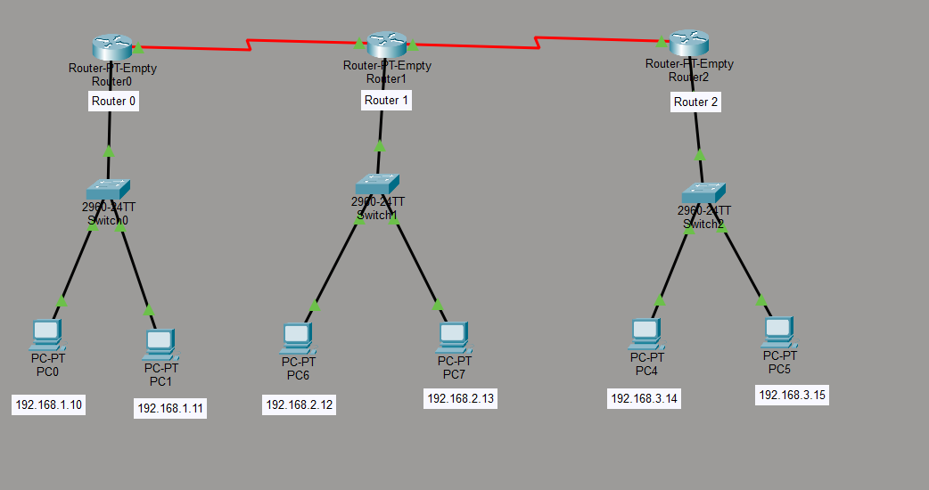

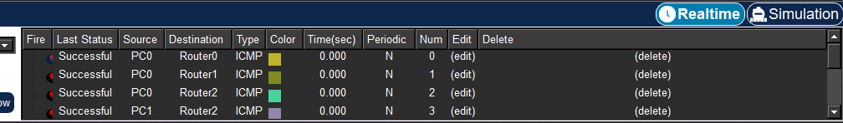

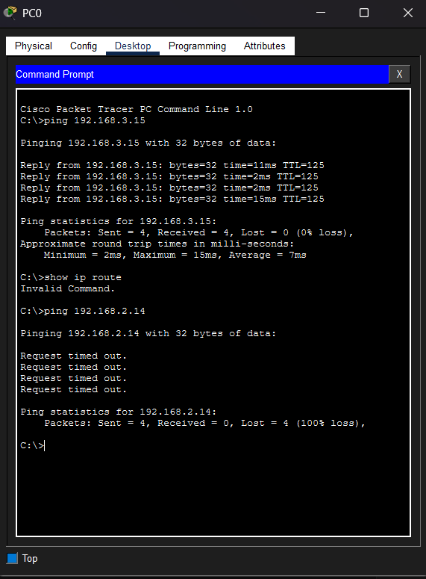

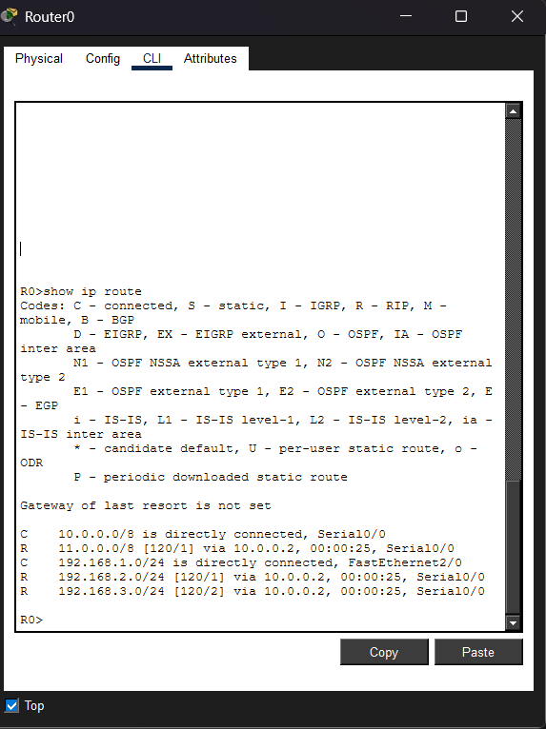

Task B: OSPF Simulation in Cisco Packet Tracer
1. Use the Same Topology or Create a New One
Use the same 3-router topology:
- Router0 connected to Switch0 and PCs
- Router1 connected to Switch1 and PCs
- Router2 connected to Switch2 and PCs
Serial links:
- Router0 ↔ Router1
- Router1 ↔ Router2

2. Configure IP Addressing Properly
Use this addressing scheme:
Device | IP Address | Subnet Mask
PC0 | 192.168.1.10 | 255.255.255.0
PC1 | 192.168.1.11 | 255.255.255.0
PC2 | 192.168.2.12 | 255.255.255.0
PC3 | 192.168.2.13 | 255.255.255.0
PC4 | 192.168.3.14 | 255.255.255.0
PC5 | 192.168.3.15 | 255.255.255.0
Router interfaces:
Router | Interface | IP Address
Router0 | G0/0 | 192.168.1.1
Router1 | G0/0 | 192.168.2.1
Router2 | G0/0 | 192.168.3.1
Router0 | S0/0/0 | 10.0.0.1
Router1 | S0/0/0 | 10.0.0.2
Router1 | S0/0/1 | 20.0.0.1
Router2 | S0/0/0 | 20.0.0.2

